Nuts & Bolts of Semi–Occluded Vocal Tract Exercises in Voice Therapy: The Why, When, and How  Marci D. Rosenberg, M.S. CCC  University of Michigan |  | 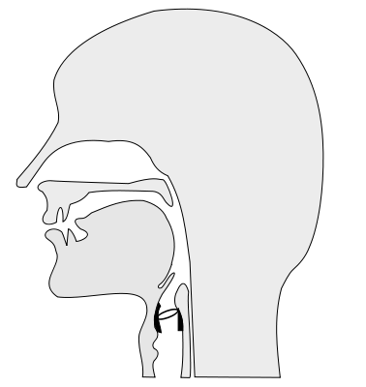
fggd
Overview  Traditional voice therapy exercises use a multitude of semi –occluded vocal tract exercises to enhance voice production. Several variations of these exercises will be introduced in a workshop format.  Objectives  The goal of this presentation is to:  - Provide and overview of the theoretical basis and physiology behind semi-occluded VT exercises  - Introduce several variations of these exercises including why, when and how to use them in voice therapy.  Semi-Occluded exercises (high resistance to less resistance)  - Use of straws & tubes  - Fricatives  - Resonance hums  - Closed vowels  Adaptations & Variations  - Wave in a Cave  - Straws and water bottles  - /o/ buzz- inverted megaphone  - Card kazoo |  | Materials  The following are a list of helpful items to use in voice therapy:  - Stirring straw  - Drinking straw  - Styrofoam cup  Resources  Principals of Voice Production (1994) Ingo Titze , Prentice Hall  Vocology The Science and Practice of Voice Habilitation (2012) Ingo Titze & Katherine Verdolini Abbott, NCVS  Nonlinear source-filter coupling in phonation: Theory. (2008) Journal of the Acoustical Society of America, 123 (5), 2733-2749  Voice Training & Therapy With a Semi-Occluded Vocal Tract (2006). Journal of Speech, Language , and Hearing Research, 49, 448-459  Exercises for Voice Therapy 2nd Ed (2013), Behrman & Haskell  National Center of Voice and Speech website- http://www.ncvs.org  Marci D. Rosenberg- marcied@umich.edu

